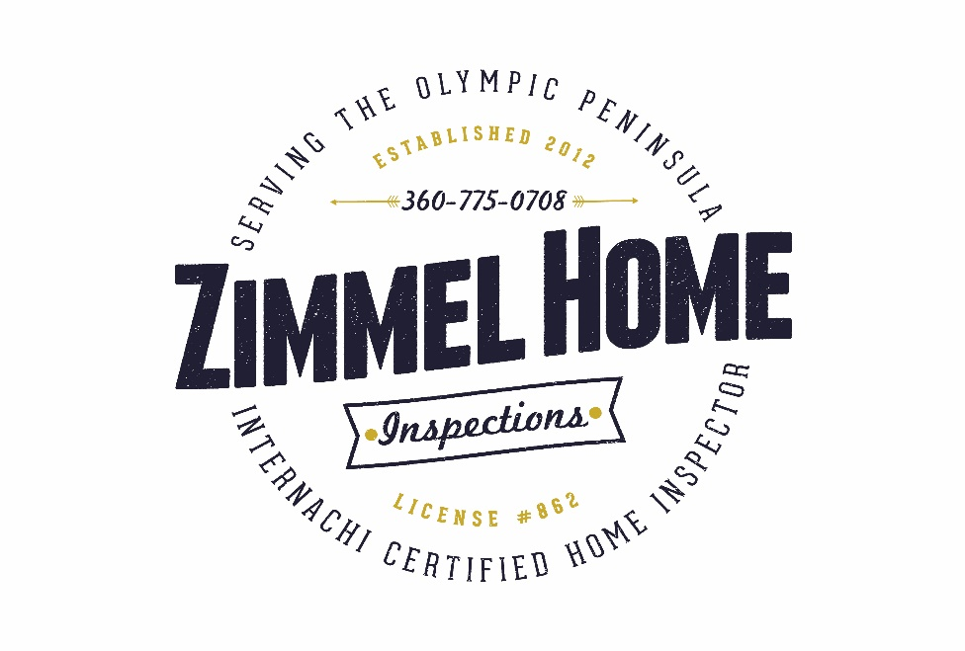
Tyson Zimmel #87491
(360)775.0708
zimmelhomeinspections@yahoo.com
zimmelhomeinspections.com

WOOD DESTROYING ORGANISM INSPECTION STANDARDS of the WASHINGTON STATE PEST MANAGEMENT ASSOCIATION

COMPLETE WOOD DESTROYING ORGANISM (WDO) INSPECTION REPORT. This report is prepared from an inspection conducted by a Washington State Department of Agriculture licensed Structural Pest Inspector in accordance with Washington Administrative Code 16-228-2005 through 16-228-2045. Opinions contained herein are based on conditions visible and evident at the time of the inspection. This report does not warrant, represent, or guarantee that the structure reported on is free from evidence of WDO's, their damage, or conditions conducive to WDO's; nor does it represent or guarantee that the total damage, infestation, or infection is limited to that disclosed in this report. I. INSPECTION PROCEDURES The inspector shall make a thorough inspection, using accepted methods and practices, of the subject to render an opinion on the presence of, or damage from WDO's as well an conditions conducive to such WDO's. AREAS INSPECTED shall include: structural exterior (accessible both visibly and physically to an inspector at ground level); accessible structure interior; accessible sub structural crawl space(s); garages, carports and decks which are attached to the structure. Deck inspection shall include; railings, wooden steps, and accessible wooden surface materials, as well as deck substructures which are accessible (those with at least a 5 foot soil to joist clearance, or elevated decks which can be suitably reached using a 6 foot step ladder). WOOD DESTROYING ORGANISMS shall include: subterranean termites; dampwood termites; carpenter ants; moisture ants; wood boring beetles of the family Anobiidae; and wood decay fungus (rot). The inspector will not assume any responsibility for WDO's that were not detected during their dormant season. When evidence of moisture ants, dampwood termites, wood infesting anobiids, or wood decay fungi is detected during a Complete WDO Inspection, the inspector must identify and report the condition(s) conducive to such infestations. It must be stated in the report that such infestations may be eliminated by removal of all infested wood and correction of any contributing conducive conditions. CONDUCIVE CONDITIONS, as determined by the inspector, shall include, but not be limited to: inadequate clearance; earth to wood contact; conducive debris in the crawl space; inadequate ventilation; excessive moisture; vegetation contact with the structure; bare ground in the crawl space; existing or seasonal standing water in the crawl space; failed caulking or grout in water splash areas; and/or non-functioning gutter systems. II. LIMITATIONS OF INSPECTIONS The inspecting firm shall not be held responsible by any party for any condition or consequence of WDO's which is beyond the scope of inspection. The scope, defined in Section I, INSPECTION PROCEDURES, is limited as follows: (a) INACCESSIBLE AREAS: Certain areas of a structure, which are inaccessible by their nature, may be subject to infestation by WDO's yet cannot be inspected without excavation or unless physical obstructions are removed. Such areas include, but are not limited to: wall voids; spaces between floors; substructures concealed by sub-floor insulation or those with inadequate clearance; floors beneath coverings; sleeper floors; areas concealed by furniture, appliances, and/or personal possessions; and deck substructures with less that 5 foot clearance. (b) ROOF SYSTEMS AND ATTIC AREAS: Roof systems, roof coverings and attic areas are excluded from this report. This report may note, at the discretion of the inspector, visual evidence of infestation and/or infections of WDO's in the portions of the eaves that are visible and accessible from the ground. Nor opinion is rendered nor guarantee implied concerning the watertight integrity, the condition, or the future life of the roof system. Any comment(s) made regarding an obvious condition of (a) component(s) of the roof system or attic space(s) shall not imply an extension to the scope of inspection. If a more qualified opinion is desired, the services of a licensed roof system professional should be obtained. (c) SHEDS AND OUTBUILDINGS: Sheds, garages, carports, decks and other structures, which are not attached to the main structure by a roof system or foundation, are excluded from this report unless specifically requested and noted. The inspecting firm reserves the right to charge additionally to inspect any unattached structures. (d) CLIMATIC CONDITIONS: In certain geographical areas of Washington State where wet climate is common, and due to their construction and materials, structures may be subject to conditions from normal weathering. Such conditions as cracking, checking, and/or warping of doors, window casings, siding, and non-supporting wooden members shall not be reported on inspection reports
except at the discretion of the inspector. Inspectors are not required to report on any wood destroying organism infestation, infection, or other condition that might be subject to seasonal constraints or environmental conditions if evidence of those constraints or conditions is not visible at the time of the inspection. (e) MOLD: Molds, mildews, and other fungal growth (except wood decay fungi) shall be reported on only to the extent that they indicate an excessive moisture condition which may be conducive to WDO's. The inspector is not liable or responsible for determining the type of mold, mildew, or other fungi present, nor shall the inspector be liable or responsible for determining the possible health hazards associated with the presence of molds, mildews, or other fungi. This report is not, nor shall the inspector perform a mold inspection or investigation. If a more qualified opinion is desired, the services of a toxicologist or certified industrial hygienist should be obtained. (f) STRUCTURAL ASSESSMENT: While it may be possible for the inspector to note damaged materials, neither the inspector nor the inspection firm is liable or responsible in any way to determine the structural integrity of any building materials. If a more qualified opinion is desired, the services of a licensed, qualified contractor or structural engineer should be obtained. (g) REMAINING EVIDENCE: In certain situations, it may not be practical to eliminate all evidence of previous WDO activity (e.g., carpenter ant frass, insect parts, or subterranean termite scaling), or evidence of conducive conditions, (e.g., water staining). Although noted, this evidence may remain after corrections have been made or if it is the inspector's opinion that the evidence is from inactive WDOs and no corrections are recommended. Neither the inspector nor the inspecting firm shall be liable or responsible for any corrective action required by future inspections in regards to this remaining evidence. III. REPORTS (a) WRITTEN REPORT: The inspecting firm shall not issue any complete wood destroying organism report unless a Washington State Department of Agriculture licensed structural pest inspector from that firm has made a careful and thorough inspection of the structure in conformance with and subject to the limitations within these standards. Reports shall include a diagrams and a description of the findings to help identify locations of the findings as well as inaccessible areas not identified in section II (a) of these standards. IV. WORK RECOMMENDATIONS AND TREATMENTS (a) NO WARRANTIES OF CORRECTIVE WORK: Neither the inspector nor the inspecting firm will evaluate or warranty the quality of workmanship, the compliance with any applicable building codes, nor the suitability of use or any repairs, corrections, or treatments recommended within this report. Compliance with Washington State pesticide application laws and applicable building codes (current revisions) is the responsibility of the property owner and those performing the work. It is strongly recommended that those parties performing any corrections or treatments be licensed, bonded and qualified professionals providing warranted services. (b) CONDITIONS REVEALED DURING THE PERFORMANCE OF RECOMMENDATIONS: Should any WDO damage, or conducive condition be revealed during the performance of any recommendations, whether performed by the owner, the purchaser, a contractor, or any other party of interest, the inspecting firm must be notified of such, and be given a reasonable opportunity for reinspecting and determining the need for any additional corrective measures before such conditions are covered. The owner, purchaser, or any other person performing the work shall be responsible for notifying the inspector. Nothing contained herein shall prevent the inspecting firm from assessing additional charges for each additional inspection.

NOTE: The Washington State Pest Management Association (WSPMA), as a service to inspection firms, has developed this form and these Standards of Practice. By doing so, the WSPMA does not certify that the inspecting firm is a member of the WSPMA, or that the inspector is qualified to perform the inspection/. The WSPMA shall not be a party to any claim or action by the buyer, seller, or other interested party against the inspecting firm solely by reason of making this report form and these Standards of Practice available for use.
FINDINGS

NOTE: The owner(s) and/or persons performing any work relative to these findings must ensure that all construction work performed meets the standards of good construction practices and materials as provided for, and in, any and all applicable building codes (current revisions). Pest control measures must be performed by Washington State licensed applicators in conformance with all federal, state, and local laws. Nothing contained herein shall prevent the inspecting firm from assessing charges for each additional inspection.

LIMITATION OF LIABILITY

The above inspecting firm and inspector endeavor to perform their services in a professional manner consistent with the care and skill ordinarily exercised by structural pest inspection professionals. The inspecting firm will re-perform any services not meeting this standard without additional compensation. The inspecting firm's total liability for the inspections made of the inspected structure shall be limited to the amount of financial responsibility prescribed under Washington State law. The inspecting firm will not be liable for any special, incidental, punitive or consequential damages, whether foreseen or unforeseen, regardless whether liability is based on breach of contract, breach of express or implied warranty, negligence, strict liability, tort, or otherwise.

I have read and understand the above limitations and the Inspection Standards and authorize the above named inspection firm to conduct this inspection subject to the limitations and conditions therein.

This report is not valid until the Client who pays for the report signs and dates the form above, thus acknowledging the inspecting firm's Limitation of Liability provided herein.

